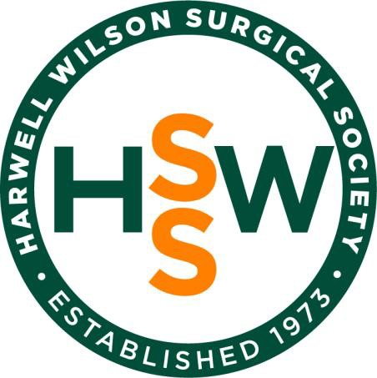

ANNUAL RESEARCH SYMPOSIUM

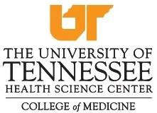

Friday, June 12th, 2026
7:30 am - 2:00 pm
University of Tennessee Health Science Center SAC Schreier Auditorium & OD Larry Dining Hall 800 Madison Avenue | Memphis, TN 38103

HWSS Annual Symposium

June 12, 2026
7:30 am Registration & Continental Breakfast
8:00 am Opening Remarks
Olivia Delozier, MD, HWSS President, Class 2020

8:05 am Welcome & Introduction of Distinguished Visiting Professor
David Shibata, MD, FACS, FASCRS
Professor and Chair, UTHSC Department of Surgery

2026 Harwell Wilson Surgical Society Distinguished Visiting Professor
Henri Ronald Ford, MD, MHA, FACS, FRCS, FAAP
Dean and Chief Academic Officer
University of Miami Miller School of Medicine

9:15 am Break (SAC OD Larry Dining Hall)

9:30 am Research Session 1:

UTHSC Faculty Moderator: Dr. Sira Duson, Vascular and Endovascular Surgery

Alumni Moderator: Dr. Zachary Stiles, Class 2021, Surgical Oncology, Roswell Park

Comprehensive Cancer Center

10:30 am Break (SAC OD Larry Dining Hall)

11:00 am Research Session 2:

UTHSC Faculty Moderator: Dr. Yasmin Ali, Trauma Critical Care

Alumni Moderator: Dr. Bennett Berning, Class 2020, Acute Care Surgery, University of Nebraska

College of Medicine

12:00 pm Lunch (SAC OD Larry Dining Hall)

12:15 pm Quick Shot Poster Presentation Session

UTHSC Faculty Moderator: Dr. Rachel Landisch, Pediatric Surgery
1:15 pm Break (SAC OD Larry Dining Hall)

1:30 pm Introduction of Invited Alumni Speaker - Paxton Dickson, MD, Class of 2009

Alicia Logue, MD, Class 2008
Leader, Colon and Rectal Surgery Program, Mays Cancer Center
Associate Professor of Surgery, University Hospital San Antonio

2:00 pm Closing Remarks

Paxton Dickson, MD, HWSS Secretary/Treasurer, Class 2009

2:05 pm Business Meeting (Members Only)

Henri Ronald Ford, MD, MHA, FACS, FRCS, FAAP
Dean and Chief Academic Officer
University of Miami Miller School of Medicine

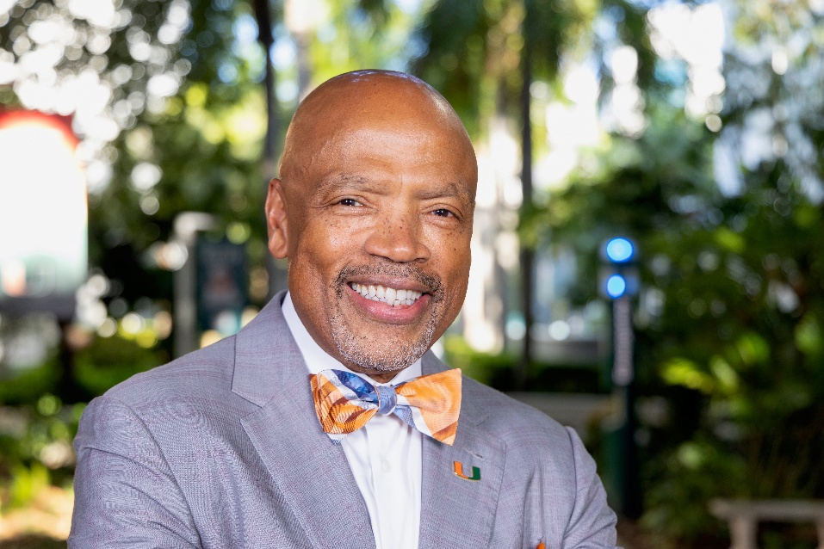
Henri R. Ford, M.D., MHA is dean and chief academic officer of the University of Miami Leonard M. Miller School of Medicine. Dr. Ford is a Haitian-born pediatric surgeon recognized for his global contributions in medicine, including performing the first successful separation of conjoined twins in Haiti in 2015, alongside surgeons he helped train. Motivated by a desire to drive change and have a positive impact on the world, Dr. Ford has conducted groundbreaking research on the pathogenesis of necrotizing enterocolitis, which has been funded by the NIH. He is the author of more than 300 peer-reviewed articles, book chapters, invited articles, abstracts and presentations. At the Miller School, Dr. Ford is developing the next generation of transformational leaders who will shape the future of medicine. Under his leadership, the Miller School has increased its research funding from the NIH from $128 million in 2018 to more than $180 million in 2025. After earning his undergraduate degree from Princeton University, Dr. Ford received his medical degree from Harvard Medical School. He then completed his surgical internship and residency at New York Hospital Weill-Cornell Medical College, a research fellowship in immunology at the University of Pittsburgh School of Medicine, and a clinical fellowship in pediatric surgery at the Children’s Hospital of Pittsburgh. He also received a Master of Health Administration degree from USC. Dr. Ford is a fellow of the American College of Surgeons (ACS), the Royal College of Surgeons (England), the Royal College of Surgeons (Edinburgh), the West African College of Surgeons, the Philippine College of Surgeons, and the American Academy of Pediatrics. He holds an honorary Doctor of Science degree from Wake Forest University. Dr. Ford serves on the editorial board of numerous scientific journals. He is a member of the National Academy of Medicine and a member of the ACS Academy of Master Surgeon Educators. He is the past president of the American College of Surgeons, the Society of Black Academic Surgeons, the Surgical Infection Society, the American Pediatric Surgical Association, and the Association for Academic Surgery, which established the “Henri Ford Junior Faculty Research Award” in his honor. He is a member of the Harvard Medical School Visiting Committee. He served on the Board of Trustees of Princeton University, the Board of Directors of the Association of American Medical College (AAMC), and chaired the Council of Deans of the AAMC. He is the recipient of numerous honors, including the Gold Humanism in Medicine award from the AAMC, the Arnold Salzberg mentoring award from the Surgical Section of the American Academy of Pediatrics, the Rehbein Medal from the European Pediatric Surgical Association for lifetime contributions to pediatric surgery, the Owen Wangensteen Scientific Forum Award from the ACS, which recognizes iconic figures in academic surgery for their leadership, mentorship, and scholarship, to name a few.

Alicia Josephine Logue, MD
Leader, Colon and Rectal Surgery Program, Mays Cancer Center
Associate Professor of Surgery, University Hospital San Antonio

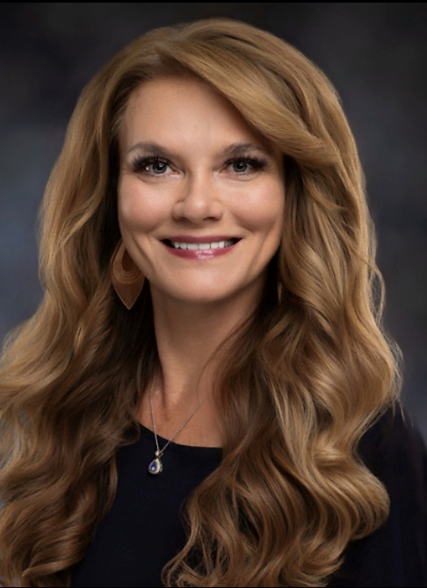
Alicia J. Logue, MD, is Associate Professor of Surgery and the Division Chief of Colon and Rectal Surgery at UT Health San Antonio. She serves as Leader of the Colorectal Surgery Service Line at the Mays Cancer Center, Cancer Liaison Physician for the Commission on Cancer at University Health, and Medical Director of UT Health San Antonio Colorectal Clinical Services.
Dr. Logue is board-certified in general surgery and colon and rectal surgery, having scored in the top 5 nationally on the colon and rectal qualifying examination. Her clinical focus includes colorectal cancer, diverticulitis, and inflammatory bowel disease, and she is a robotic enthusiast. She has been a faculty member at UT Health San Antonio since 2008 and served as Associate Program Director of the General Surgery Residency Program for more than a decade, helping train and mentor generations of surgical residents and medical students.
A recognized surgical educator, Dr. Logue, found her life passion in surgical training, mentorship, lifelong career support, and professional development. She has received numerous clinical and educational awards, including the UT Health San Antonio Master Clinician Award in 2025, multiple Excellence in Resident Education Awards, and recognition for outstanding contributions to physician assistant education. Dr. Logue is widely recognized for her commitment to surgical education, having received 11 resident teaching awards—placing her among the most highly awarded faculty educators in the 52-year history of the UT Health San Antonio General Surgery Residency Program. In addition to mentoring surgical residents, she is actively involved in the mentorship of program graduates, the institution's junior faculty, and medical students.
Dr. Logue has served as an Intuitive Surgical robotic surgery instructor and Lead Colorectal Faculty for the Texas Association of Surgical Skills Laboratories (TASSL) statewide robotic colorectal surgery program. Through these roles, she has helped educate residents as well as help practicing surgeons build robotic programs in Texas to the southern border.
Her academic interests include colon cancer, rectal cancer, surgical education, and quality improvement. Dr. Logue has been the moderator of the Department of Surgery Morbidity and Mortality conference since 2019, where she promotes honest, thoughtful, and collegial discussions to promote continuous learning. She believes that combining the highest standards of clinical care and accountability with candid discussions and collegiality is one of the most powerful ways we can improve the care we provide to patients. She has also authored numerous peer-reviewed publications and presentations and is a frequently invited speaker and moderator at regional meetings.
Dr. Logue loves helping colleagues navigate the unique challenges of surgical practice and the nuanced life of a surgeon. She finds a strong sense of purpose in being able to enhance career satisfaction, professional and personal evolution, camaraderie, and long-term retention in the field. She is the founder of Facebook's Women in Surgery Support Group, an international mentorship and professional development community with more than 1,500 members worldwide.
Dr. Logue is equally dedicated to caring for patients with colorectal disease and cancer, taking pride in providing access to top notch care and education to all who entrust her. She believes that one of the most important legacies a surgeon can leave is to share their skills with others and support their professional growth, thereby expanding access to high-quality surgical care for generations of patients beyond those they will personally treat.

HWSS Annual Symposium Presenters

Session 1: Translational Science and Surgical Oncology Research

Moderators: Dr. Sira Duson and Dr. Zachary Stiles
- “PET-CT or Wait and See? Routine Cross-Sectional Imaging in High-Risk Gene Expression Profiling Cutaneous Melanoma”

Presenter: Daniel Gehle, MD

- “Hybrid Genomic Landscape of Combined HCC-iCCA Defines a Continuum Between HCC and iCCA.”

Presenter: Michael Spinrad, MD

- “PAX6: An epigenetically regulated candidate tumor suppressor in HPV-associated head and neck cancers.”

Presenter: Julia Pedo Freitas, MD

- "Developmental Reprogramming Underlies Chemotherapy Resistance in Favorable-Histology Wilms Tumor."

Presenter: Andrew Fleming, MD

“Adjuvant Therapy for T1-T3, N0, R0 Extrahepatic Cholangiocarcinoma: A National Perspective"

Presenter: Gabriela Aitken, MD

"Utilizing ctDNA in Pre-Operative Workup of Breast Cancer."

Presenter: Linnea Cripe, MD

Session 2: Multispecialty Clinical and Outcomes Research
Moderators: Dr. Yasmin Ali and Dr. Bennett Berning
- "Is segmentectomy or wedge resection appropriate for stage IB non-small cell lung cancer ≤2cm with visceral pleural invasion?"

Presenter: Calvin Jung, MD

- “Neoadjuvant Chemoimmunotherapy in Distal Esophageal Adenocarcinoma: A Real-World NCDB Analysis.”
Presenter: Andrei Gurau, MD

- “The Impact of Fathers and Male Role Models on Recovery and Resilience in Pediatric Victims of Violent Trauma.”
Presenter: Kevin Lang, MD

- “Nutritional Deficits and Pressure Injury Risk in Pediatric and Adolescent Spinal Cord Injury: A Dual-Center Study.”

Presenter: Julia Firnhaber, MD

- “Endovascular Therapy is an Essential Component in the Management of Complex Pediatric Vascular Pathologies: Experience from Two Major Academic Trauma Centers.”

Presenter: Hamda Almaazmi, MD

- "Efficacy of Ultrasound Guided Drainage of Abscesses in the Perioperative Appendectomy Period."

Presenter: Mariah Perkins, MD

HWSS Annual Symposium Presenters

Session 3: Quick Shot Research Presentations

Moderator: Dr. Rachel Landisch
- "Is Early Initiation of Antibiotic Therapy in Critically Ill Trauma Patients with Ventilator Associated Pneumonia an Appropriate Quality Metric?"

Presenter: Neeraj Namburu, BS

- "Editorial Self-Publication in Cardiothoracic Surgery Journals."

Presenter: Emma Levine, MD

- "Perineal hernia repair using double-layer synthetic macroporous mesh."

Presenter: Jasmine Puria, BS

- “Close Calls, Closed Abdomens: Nonoperative Success in Pediatric Penetrating Abdominal Trauma.”

Presenter: Daniel Gehle, MD

- “Routine 4L Node Retrieval in the Era of Robotic Surgery for Left-sided Lung Cancer: an Analysis of Safety, Efficacy and Potential Benefits.”

Presenter: Theresa Dinh, MD

- "Ipsilateral Isn’t Inferior: Vein Graft Laterality Likely Does Not Impact Outcomes After Lower Extremity Revascularization in Trauma."

Presenter: Jeremy Banks, BS

- "Leveraging AI-Powered Sentiment Analysis to Decode Public Opinion on HIPEC across Disease Sites and Digital Platforms."

Presenter: Bassam Beshara, BA

- “Management of R0 Resected pN0 Stage I-IIIA Intrahepatic Cholangiocarcinoma: A National Perspective.”
Presenter: Andrew Fleming, MD

- " Robotic Intracorporeal Resection of an Extra-enteric Malignant Gastrointestinal Neuroectodermal Tumor of the Chest Wall: A Case Report."

Presenter: Tari-Ann Yates, MD

- “Pediatric Trauma Centers Achieve Comparable Survival in Critically Injured Adolescents Requiring Hemorrhage-Control Operations.”

Presenter: Kevin Lang, MD

- “Characterizing Contemporary Management of Major Pediatric Vascular Trauma: A Multiyear, Dual-Center Retrospective Analysis.”

Presenter: Hamda Almaazmi, MD

CONGRATULATIONS!!
2026 Graduates

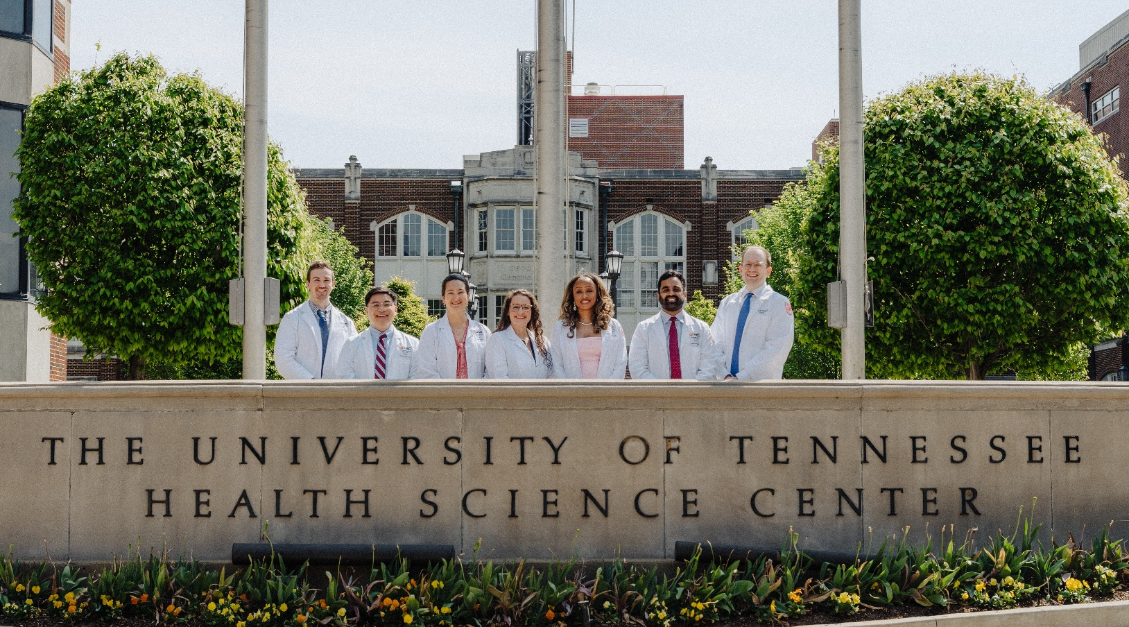

Left to Right:
Brenden Sheridan, MD, Ladd Caballero, MD, Linnea Cripe, MD, Lillian Malach, MD, Tari-Ann “Tariana” Yates, MD, Kaushik Varadarajan, MD, Andrew Fleming, MD

2026 HWSS INDUCTEES

GRADUATING RESIDENTS

Ladd Caballero, MD Lillian Malach, MD
Linnea Cripe, MD Brenden Sheridan, MD
Andrew Fleming, MD Kaushik Varadarajan, MD
Tari-Ann “Tariana” Yates, MD

GRADUATING FELLOWS

Gabriella Aitken, MD (Surgical Oncology) | Hamda Almaazmi, MD (Vascular Surgery)
Benjamin Dixson, MD (Vascular Surgery) | Amanda B. Dooley, MD (Surgical Critical Care)
Megan Lehrman, MD (Surgical Critical Care) | Elizabeth Mannino, MD (Surgical Critical Care)
Akila Ramaraj, MD (Pediatric Surgery) | Jayasai Varre, MD (Surgical Critical Care)

NEW FACULTY
Jason Frischer, MD
Leanne Grafmuller, MD
Saloni Mehrotra, MD
Muntazim Mukit, MD
Chelsea Olson, MD
Chinmayee Potti, MD
Jessica Staszak, MD
Thao Wolbert, MD

DISTINGUISHED VISITING PROFESSOR
Henri Ronald Ford, MD, MHA, FACS, FRCS, FAAP

ALUMNI VISITING PROFESSOR
Alicia Josephine Logue, MD

Black Tie Event

PEABODY HOTEL | Roof Top and SkyWay| 118 S. 2nd Street

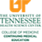   | AMA Credit Designation: The University of Tennessee College of Medicine (UTCOM) designates this live activity for a maximum of 4.25 AMA PRA Category 1 CreditsTM. Physicians should claim only the credit commensurate with the extent of their participation in the activity.  Continuing Education for Non-Physicians: The UTCOM will issue Certificates of Participation to non-physicians for participating in this activity and designates it for CEUs using the national standard that 1 hour of educational instruction is awarded .1 CEU.  Accreditation: The UTCOM is accredited by the Accreditation Council for Continuing Medical Education (ACCME) to provide continuing medical education for physicians.

